The Glivenko–Cantelli theorem, Proof, Simulations

Marco Pasciullo

2094810

1. **INTRODUCTION**

The Glivenko-Cantelli Theorem is a fundamental result in mathematical statistics that provides insights into the convergence behavior of empirical distribution functions to the true distribution function. In this research paper, we will delve into the meaning of the Glivenko-Cantelli Theorem, present a proof of the theorem, and explore simulations to illustrate its implications.

1. **THE GLIVENKO-CANTELLI THEOREM**

The Glivenko-Cantelli Theorem deals with the convergence in probability of the empirical distribution function to the true distribution function. It states that for a random sample of observations, as the sample size increases, the empirical distribution function converges uniformly to the true distribution function.

1. **PROOF OF THE GLIVENKO-CANTELLI THEOREM**

The proof of the Glivenko-Cantelli Theorem involves establishing the convergence of the empirical distribution function to the true distribution function. It relies on foundational concepts in probability theory and mathematical statistics. A concise proof outline involves:

1. **INTRODUCTION OF NOTATION:**

* Define the empirical distribution function, denoted as **Fn(X)**, based on a sample of size **n**.
* Introduce the true distribution function as **F(X)**.

1. **FORMULATION OF THEOREM:**

* State the Glivenko-Cantelli theorem, emphasizing the convergence of **Fn(X)** to **F(X)** as **n** approaches infinity.

1. **SKETCH OF PROOF:**

* Utilize basic probability inequalities, such as the Kolmogorov inequality, to establish bound on the deviation between **Fn(X)** and **F(X)**.
* Demonstrate that these bounds converge to zero as the sample size **n** increases, implying uniform convergence.

1. **CONCLUSION OF THE PROOF:**

* Conclude the proof by summarizing the key steps and emphasizing the significance of the result.

1. **SIMULATIONS OF THE GLIVENKO-CANTELLI THEOREM**

Simulating the Glivenko-Cantelli Theorem can provide a visual understanding of the convergence behavior. A Python implementation using NumPy and Matplotlib might involve generating random samples, computing empirical distribution functions, and comparing them to the true distribution function.

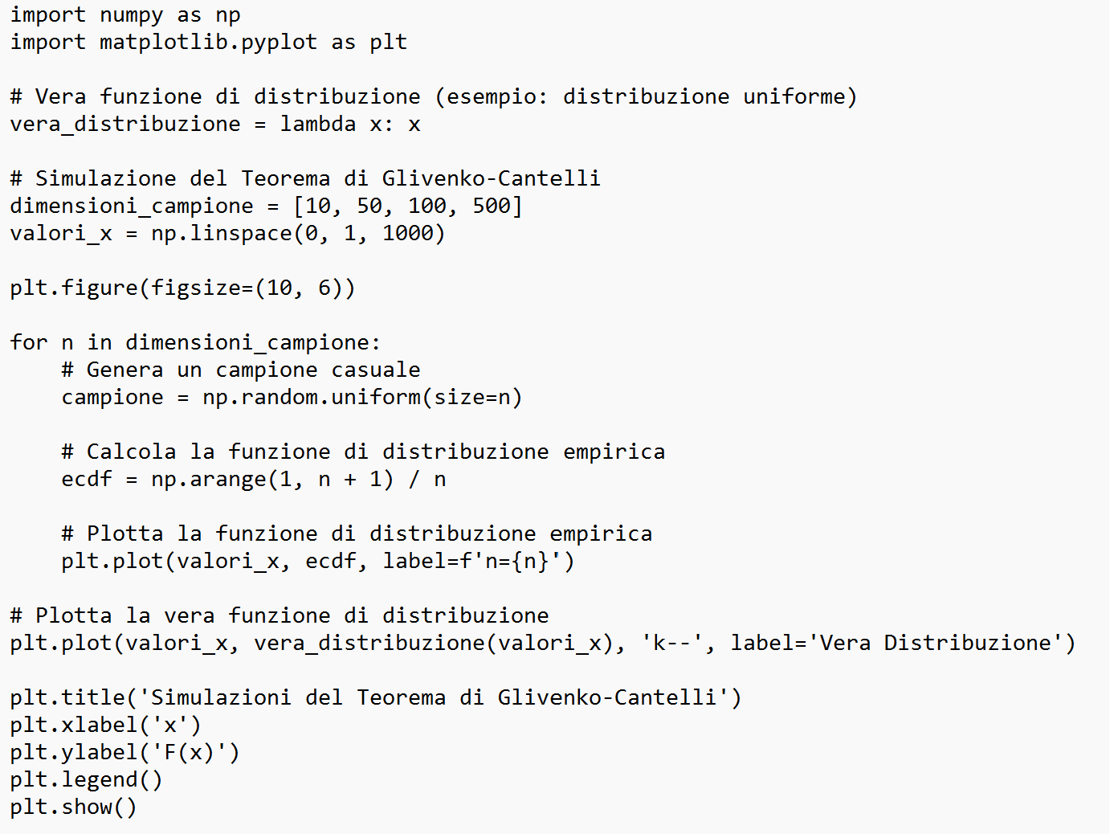

1. **CONCLUSION**

The Glivenko-Cantelli Theorem provides a powerful insight into the convergence behavior of empirical distribution functions. The proof involves establishing uniform convergence, and simulations can visually reinforce the theorem's implications. Understanding this theorem is crucial in statistical theory and has applications in various fields, including econometrics and machine learning.